***Manual for obtaining the Harmonized Alphanumeric Carrier Code (CAAT)***

***Objective:***

One of the main objectives of the Mexican Association of Shipping Agents, A.C. (AMANAC) is to provide to its partners and associates, specialized advisory services in economic, administrative and legal matters, as well as technical support, among many other activities that are carried out for the maritime and port sector, seeking to be a benchmark in the training of members and the study of the transport sector and therefore the international maritime trade.

Derived from the above, this association wants to continue contributing to the optimization of times in the procedures for our partners and associates, specifically regarding the obtention and renewal of the Harmonized Alphanumeric Carrier Code (CAAT), for which it has structured the following manual for the following profiles:

• CAAT Maritime profile

General Rules of Foreign Trade (RGCE)

• Foreign trade rules for maritime transmissions: 1.9.8 / 1.9.22 (shipping lines)

**Access to the Single Window System X12 testing environment**

The user will enter the Single Window portal for the trial version through the following web address

<https://wwwqa.ventanillaunica.gob.mx/vucem/index.html>

Once you have entered the Single Window website, the main page will be displayed, which will show an icon of a fingerprint in the lower right corner, when you click it will ask the applicant for the login information.

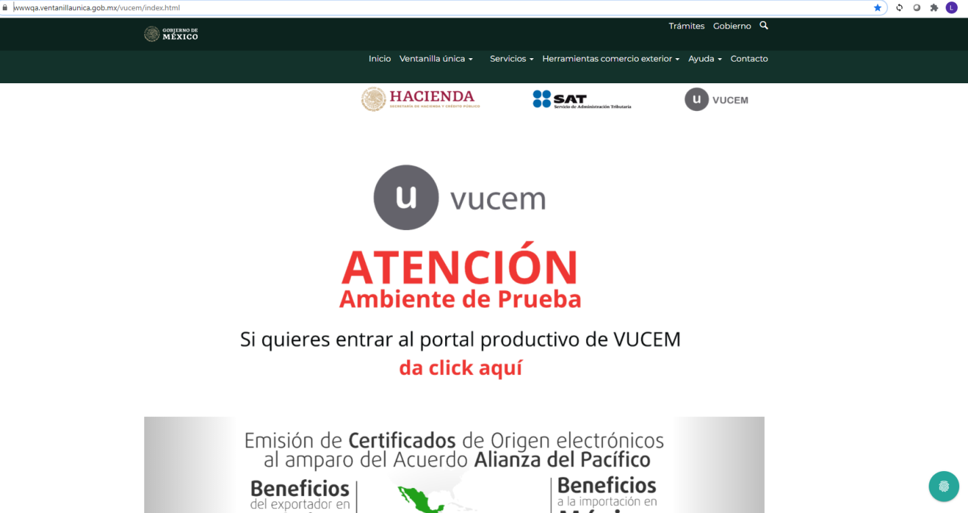

**Access to users with FIEL (advanced electronic signature)**

Users with FIEL: These are Natural or Legal persons who have a Private Key (file with * .key extension), Certificate (file with * .cer extension) and a password for the private key.

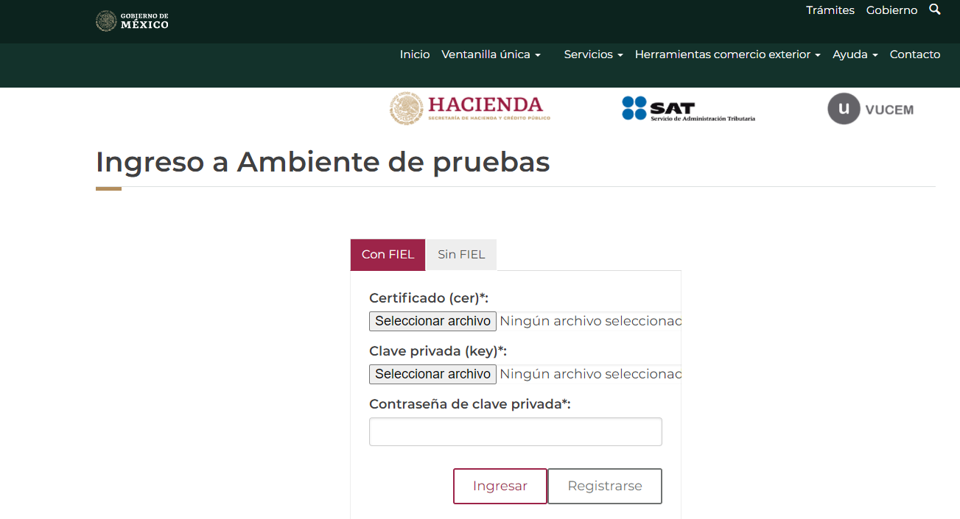

Press "select file" and find the location of the private key (* .key), then click on open and load the file.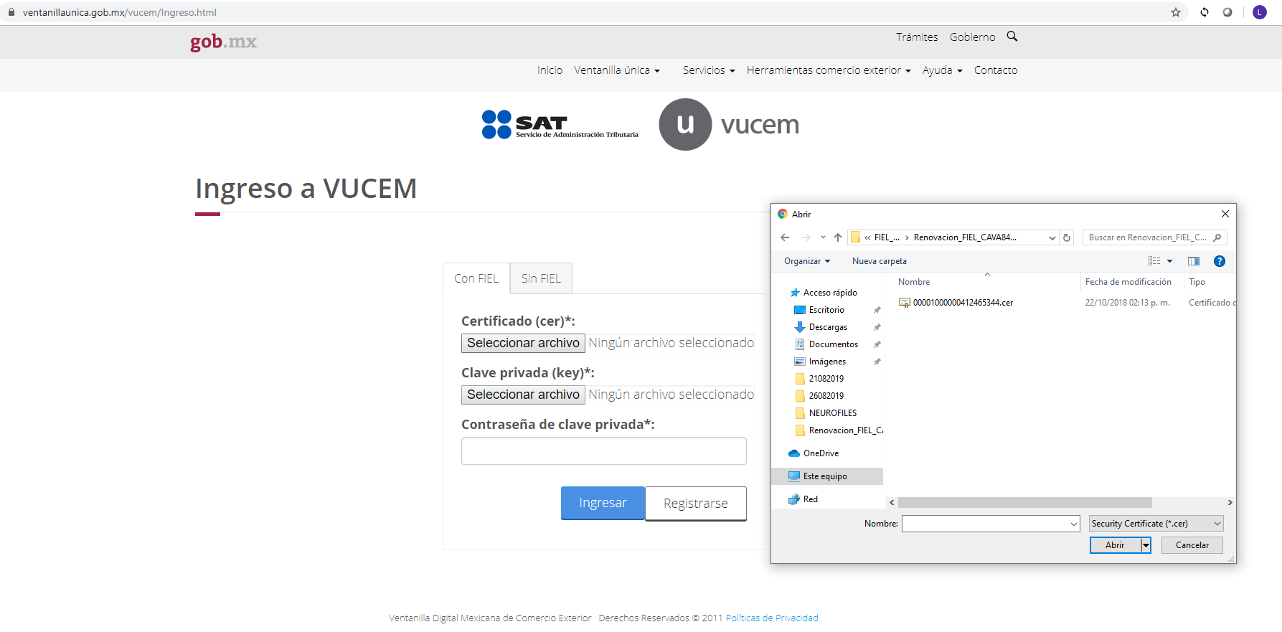

Press "Select file" and find the location of the certificate (* .cer), then click on open in order to load the aforementioned file.

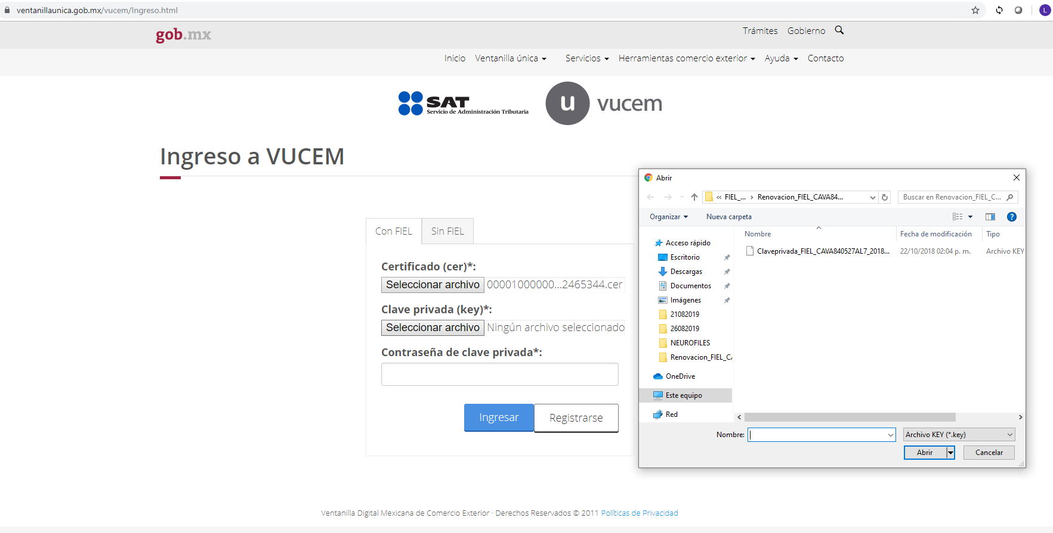

Input the FIEL password, once all the required data data has been entered and correspond to the RFC (Mexican Tax ID) that was entered, press the enter icon.

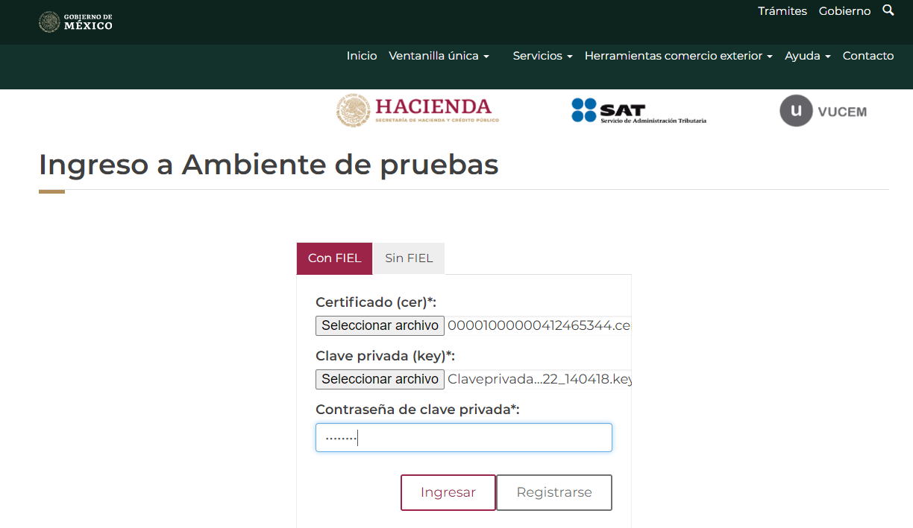

In the event that the information of the Private Key (file with * .key extension), Certificate (file with * .cer extension) and / or the password of the private key key are wrong, the following error will be displayed:

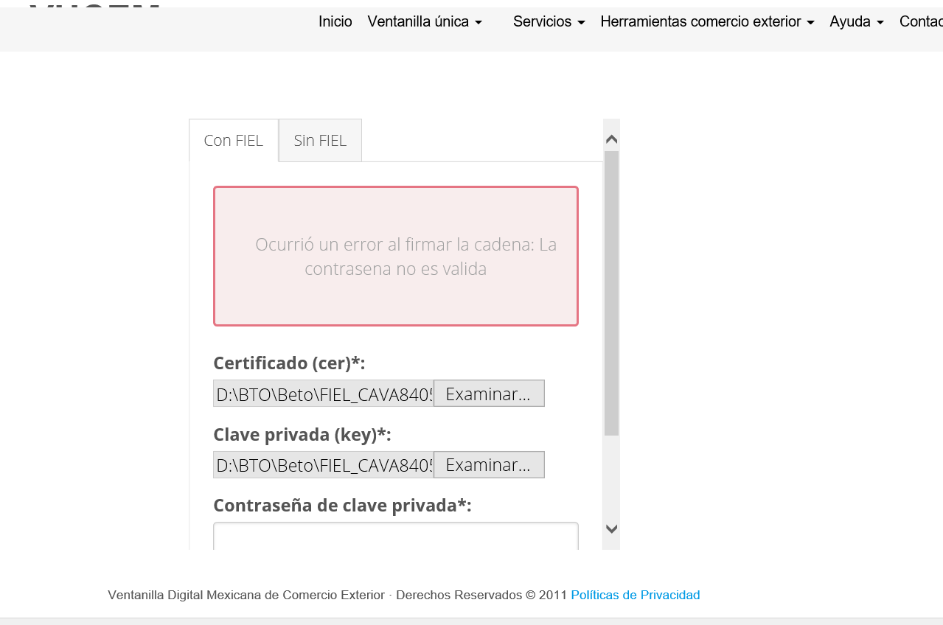

The data entered must be verified and the previous procedure carried out again, in order to allow us access to the main page of the Single Window, in the corresponding procedure.

Once entering, must select the company name and the RFC that the web page shows in the upper right corner and copy it to a notepad, because that information will be used to obtain the key for sending files through web services (Characters chain).

Once the above action has been carried out, select new procedures and applications.

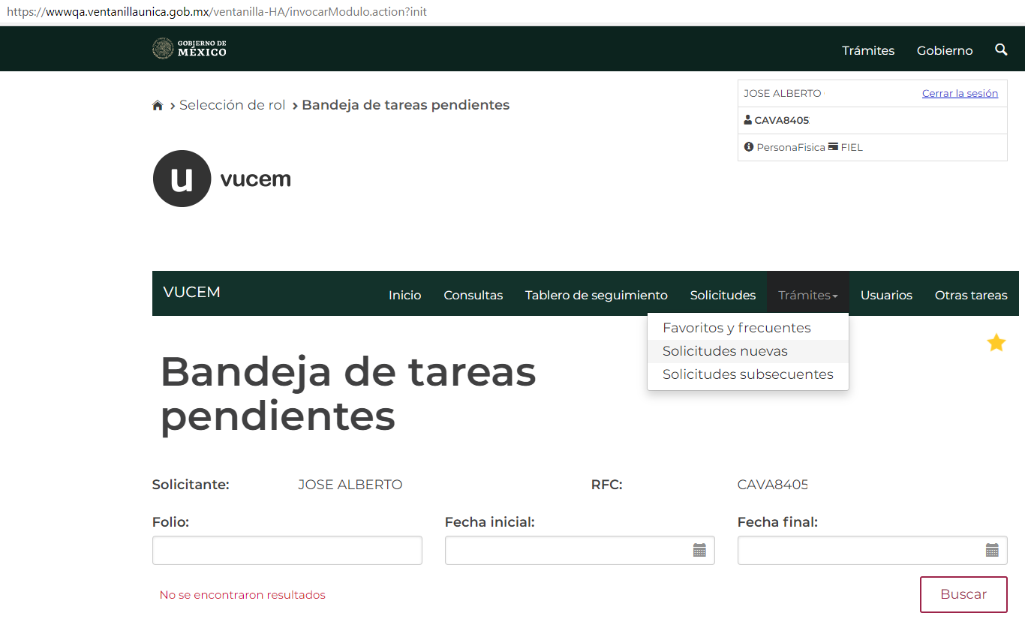

Then click on the Finance Ministry icon (Hacienda).

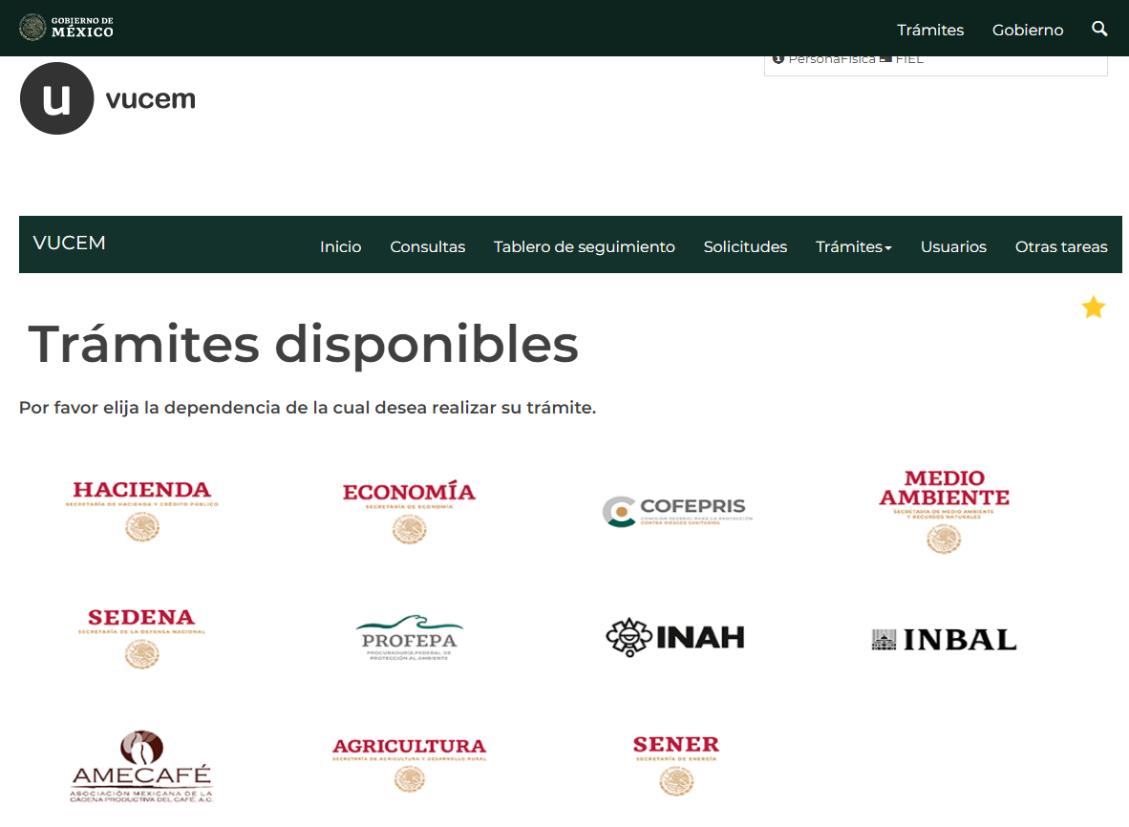

Click on Record of the Harmonized Carrier Code and information will be displayed, select the option marked in the red box, as shown below:

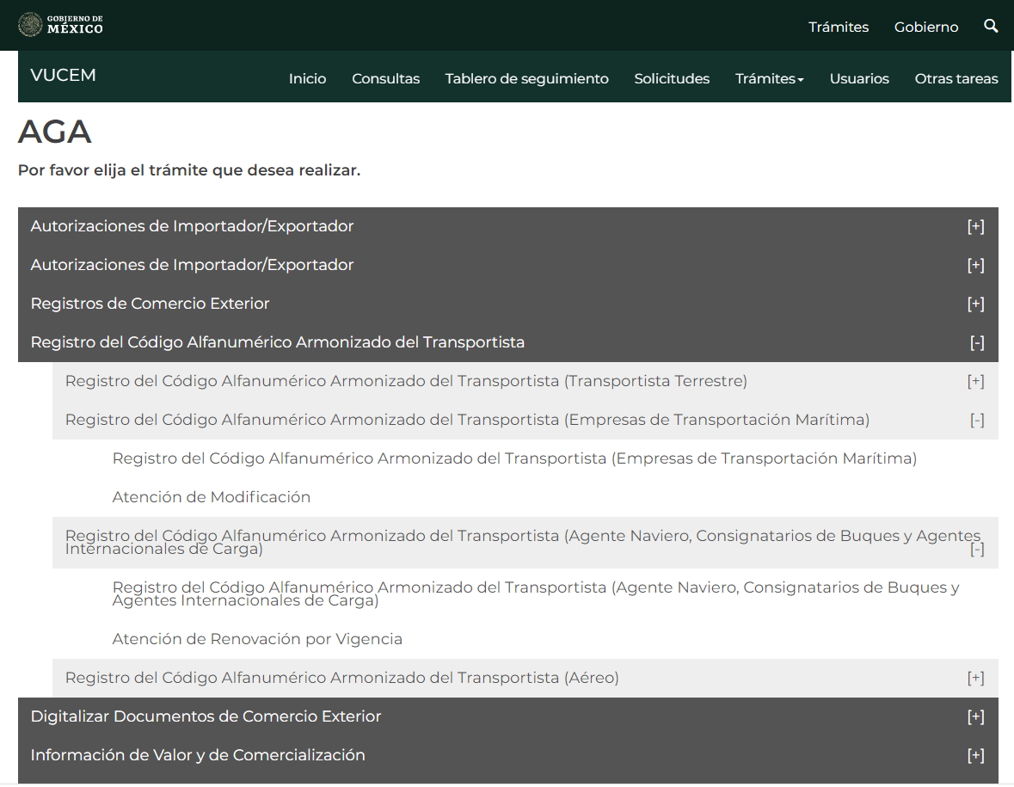

Must input the required data in the applicant and process data tabs, once completed you must press “Return”.

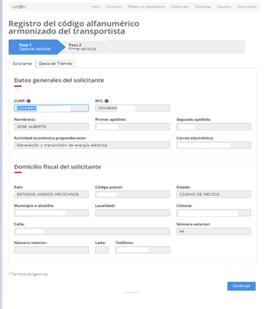

Once the corresponding data is finished, sign with the FIEL and download the corresponding acknowledgment.



Shipping agent acknowledgment example:

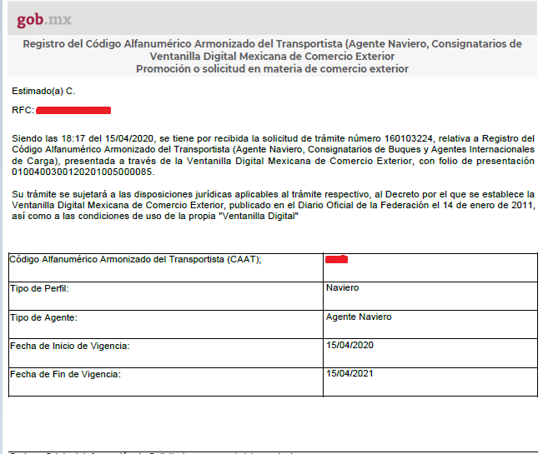

Before closing session, it is important to validate which email you have registered in the Single Window, for this, select the user menu, click on the plus sign icon and it will show you two options, you will select the option to change the email account or if the one that is registered is correct, you will close the session, since that email will receive the password for sending files through web services that is mentioned later in this manual.

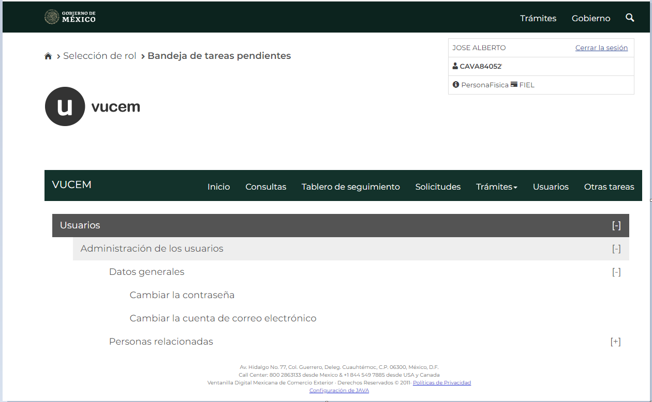

**Obtaining the key for sending files through web services (character string)**

The user will enter the Single Window portal through the following web address

<https://wwwqa.ventanillaunica.gob.mx/vucem/Ingreso.html>

Once you have entered the Ventanilla Unica website, a screen will be displayed where you must select the tab that says SIN FIEL and then ¿Olvidaste tú contraseña? (forgot your password?) in order to obtain the password for sending files through web services (string of characters) to be able to have the link in the SAT environment and thus be able to carry out the tests with the corresponding credentials.

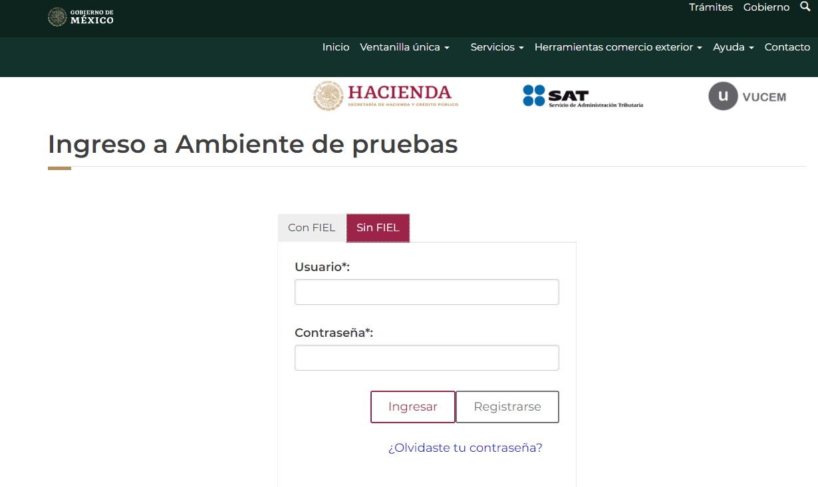

Once you go to the following windows, you must input the requested information depending on the type of person you are (legal or physical), once the information is input and clicking the retrieve button, you will receive the email registered in the VUCEM username, password and key for sending files through web services (character string), as shown below:

