Free Translation

**Guidelines containing the technological requirements for the transmission to the Digital Window of the cargo manifest in maritime traffic.**

October 2020

**VERSIONS CONTROL**

|  |  |  |  |
| --- | --- | --- | --- |
| **VERSION** | **DATE** | **PREPARED BY** | **COMMENTS** |
| 1.1 | June 2020 | Central Administration of  Customs Modernization | First version. |
| 1.2 | August 2020 | Central Administration of  Customs Modernization | Flowchart adjustment. |
| 1.3 | October 2020 | Central Administration of  Customs Modernization | Guidelines title modified and wording adjustments. |

**Versions control** 2

**I.** **Introduction.** 3

**II.** **Purpose.** 4

**III.** **Legal Framework** 4

**IV.** **Glossary of Acronyms and Definitions** 5

**V.** **General Considerations.** 6

**VI.** **General Flow Charts** 9

**VII.** **Web services** 11

**a)** **WS Implementation** 11

**b)** **EDI 309 SO Message** 12

**c)** **Types of EDI 309 SO message, pursuant to the operation:** 12

**1.** **Manifest 12**

**2.** **House bill of lading. 12**

**3.** **In case of vessels in ballast 12**

**4.** **Empty container 12**

**5.** **Local coastal trade manifest 13**

**6.** **Frequent errors when transmitting a 309 SO message 13**

**7.** **The addendums and deletions, amendments to the 309 SO (ADR) message 13**

**8.** **Add a bill of lading 13**

**9.** **Deletion of a bill of lading 14**

**10.** **Replace or amend one or all of the segments of the bill of lading 14**

**11.** **Errors when making an addendum. 14**

**12.** **Frequent errors when replacing or amending 15**

**13.** **Responses 997 and 355 16**

**VIII.** **Queries in the Internet webpage.** 17

**1.** **Query of 309 message** 17

**2.** **Container query** 18

**3.** **House bill of lading query** 20

**4.** **Manifest Query** 21

**5.** **Master bill of lading query** 22

**6.** **Log query** 24

**7.** **Manifest query** 25

# **Introduction.**

On January 14th, 2011, the Official Gazette published the Decree establishing the Mexican Digital Window for Foreign Trade, whose object is to allow the users to carry out procedures, promotions, or requests regarding imports, exports, and transit of foreign trade goods, by means of a single electronic point of entry.

Pursuant to the provisions of article 6 and 20, fractions III and VII, 36, 36-A, of the Customs Law, those who introduce or extract goods from national territory, are obligated to electronically transmit to the customs authority, the information related to the goods and its transportation, prior to their arrival to national territory or its exit.

The Regulations 1.9.22. and 1.9.23. of the General Foreign Trade Rules in full force and effect, establish that the maritime transportation companies, the international freight forwarders or their authorized parties, must transmit through the Digital Window an electronic document with the information regarding the goods they transport, their means of transportation, the manifest that contains the cargo or the goods for which the maritime services were contracted, respectively.

# **Purpose.**

To publish the Guidelines with the technological specifications for the transmission to the Digital Window of the cargo manifest in maritime traffic, with the requirements and file format that the maritime transportation companies, the integrational freight forwarders, or their authorized parties must comply with, in order to carry out the electronic transmission of the information regarding the goods they transport, their means of transportation, the manifest that contains the freight or the goods for which the maritime services were contracted, respectively, by means of an electronic system to the Digital Window, pursuant to the General Foreign Trade Rules.

# **Legal Framework**

**Customs Law**

Articles 1º, 2º, fractions III, VII, and XIII, 4º, 6º, 7º, second paragraph, 20, fractions II, III, VII, and X, 36 and 36-A.

**Regulations of the Customs Law**

Article 19

**General Foreign Trade Rules (RGCE) in full force and effect**

Rules 1.1.8., 1.2.2., 1.9.22., 1.9.23., and 2.4.4.

Glossary of Definitions and Acronyms of the RGCE in full force and effect

**Other provisions**

Official Mexican Norm NOM-002-SCT4-2013, Maritime-Port Terminology, published in the Official Gazette on March 14th, 2014.

# **Glossary of Acronyms and Definitions**

For a better understanding of the provisions in these guidelines we compile the following glossary of acronyms and definitions, which includes, without limitation:

|  |  |
| --- | --- |
| **Addendum** | Add, amend, or correct the content of the message (ADR). |
| **ACMA** | Central Administration of Customs Modernization. |
| **International freight forwarders** | Individual or entity, that acts as an intermediary between the importer or exporter and the direct carrier, and provides services of transportation, consolidation, storage, handling, packaging, or distribution of products, as well as the auxiliary and counseling services, including, without limitation, those regarding the fiscal and customs matters, declaration of goods for official purposes, insurance of the products and collection or procurement of payments or documents regarding the goods. |
| **Port shipping agent** | Individual or entity that acts on behalf of the shipping company or operator, as appointed representative for all acts and arrangements entrusted in relation to the ship at the port of consignment. |
| **Baplie** | Is the electronic document by means of an EDI message, used to transmit the planning of the cargo of the container ships, between the port terminal and the shipping company. |
| **CAAT** | Alphanumeric Harmonized Code of the Carrier (SCAC Mexican equivalent). |
| **Bill of lading** | Document that fulfills the functions of a cargo transportation agreement. Title representing the goods and their receipt on board the vessel. |
| **Ballast** | Weight put on a vessel to make it submerge upto a convenient draft, or for stability purposes. |
| **Law** | Customs Law. |
| **Cargo Manifest** | Is the document containing a list of all the goods loaded at a given port, organized as a list of bills of lading and containing each one of the information elements related to the goods, origins and destinations, the parties involved, and others as required by the authorities. |
| **EDI Message** | Electronic Data Interchange is a coherent set of data, structured according to the agreed norms of message, for its transmission by electronic means. |
| **RGCE** | General Foreign Trade Rules in full force and effect. |
|  |  |
| **SAT** | Tax administration service. |
| **Local Costal Trade Manifest** | Document where the captain lists all goods that are part of a shipment. |
| **Transshipment** | Transfer of goods from one vessel to another. |
| **Electronic transmission** | The transmission of information made by means of the electronic system. |
| **Digital Window** | Mexican Foreign Trade Digital Window . |
| **WSDL** | Web Services Description Language is a format of the Extensible Markup Language (XML), used to describe web services. |
| **XML** | Extensible Markup Language, is a system that allows for a language to be defined according to the needs. |

# **General Considerations.**

1. It is the responsibility of the maritime transportation companies and of the international freight forwarders, to transmit the information regarding the goods they are transporting, their means of transportation, the cargo manifest or the goods for which the maritime services were contracted, by means of an electronic system and with an EDI 309. message to the Digital Window, pursuant to rules 1.9.22. and 1.9.23. of the RGCE.
2. The Digital Window will send an electronic acknowledgement of receipt, by means of an EDI 997. message. When the 309 message does not comply with the structure according to the specifications, the reply in the message 997 will show a rejection pointing out the errors.
3. The Digital Window will validate that the transmitted information in the EDI 309 message, complies with the required technical specifications and shall send an electronic acknowledgement of validation by means of an EDI 355 message with an acceptance code, which will be identified in segment K3, when there are 0 errors, as per following example:

When the code of acceptance is not available, it will be deemed as not transmitted.

1. The transportation companies and the international freight forwarders shall previously obtain their CAAT registry pursuant to the terms of the provisions of Rule 2.4.4. of the RGCE.
2. In order to warrant that the transmitted information is trustworthy, the maritime transportation companies, the international freight forwarders, or their authorized parties must comply with the following requirements in order to carry out the electronic transmission of the data to the Digital Window:
3. Enable a contact point 24/7/365, to deal with the problems that arise for the final users in case of any contingency, in order to timely attend and solve each one of them.
4. Implement all the web services developed by the SAT, as well as all the upgrades and updates for the sending and receipt of the XML messages.

* Web service to transmit.
* Web service to receive the replies of the Digital Window.

1. Approve the trial cases defined by the SAT, jointly with their service provider in a trial environment for volume, security, and quality of the information.
2. The authorized parties of the maritime transportation companies or of the international freight forwarders must provide the following information, by means of a free-form writ to the ACMA pursuant to the terms of Rule 1.2.2. of the RGCE:

* Name of the company and CAAT number of the companies the services will be rendered to.
* Transmission diagrams to the Digital Window specifying the IP and port of origin and destination of each implemented web service.
* URL for reception of replies from the Digital Window.
* Description of the procedure by which the system informs its users in case of any error in the transmission.

The SAT will publish by means of the Digital Window, the name, corporate or social denomination of those who are allowed to carry out transmissions for having complied with the aforementioned requirements.

It should be noted, that only those who have complied with said requirements may carry out transmissions, therefore, the omission of the respective transmission, is subject to penalties pursuant to the applicable provisions.

1. In case of goods bound to a foreign destination, that will be subject to transshipment in national territory, the transmission referred to in Rule 1.9.22. of the RGCE must be made.
2. In case of goods coming from abroad that will be subject to transshipment with final destination in national territory, that will call at other ports in the territory, the transmission referred to in Rule 1.9.22 of the RGCE must be made.
3. For the purpose of articles 6, 20, fraction VII and 36-A, fraction I, paragraph b) of the Law, once the Digital Window sends the EDI 355 message with the code of acceptance of the transmissions referred to in Rules 1.9.22. and 1.9.23. of the RGCE to the maritime transportation companies, the international freight forwarders or their authorized parties, must provide to the Customs broker, legal representative or in-house Custos agent, the bill of lading number, which will have to be declared in the Customs clearance application, register 503 referred to in the “Technical Guidelines of VOCE-SAAI M3 Registers”.

# **General flowcharts**

1. General Flow of the transmission of the maritime company, pursuant to Rule 1.9.22. de las RGCE

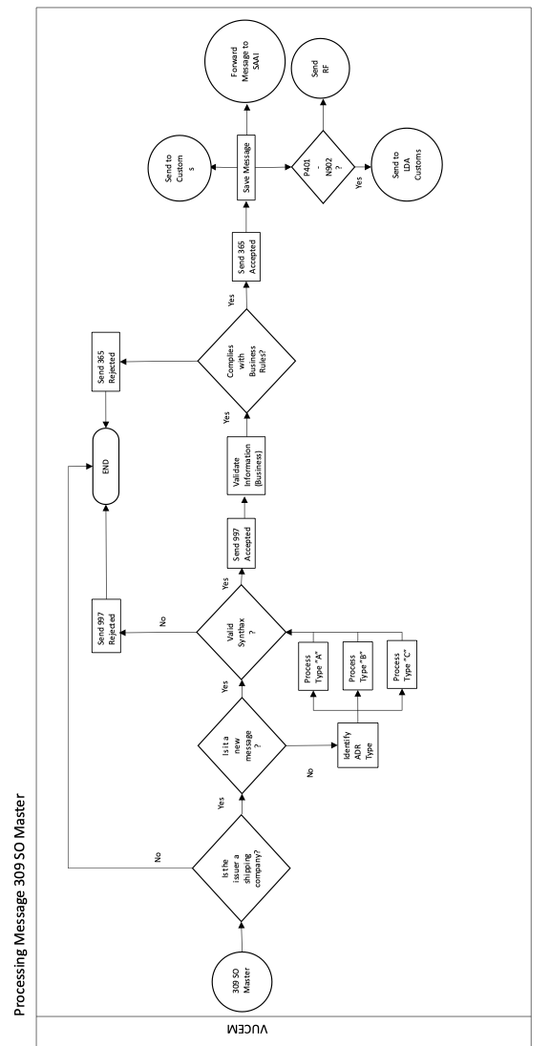

1. General Flow of the transmission of the International Freight Forwarder, pursuant to Rule 1.9.23 of the RGCE.

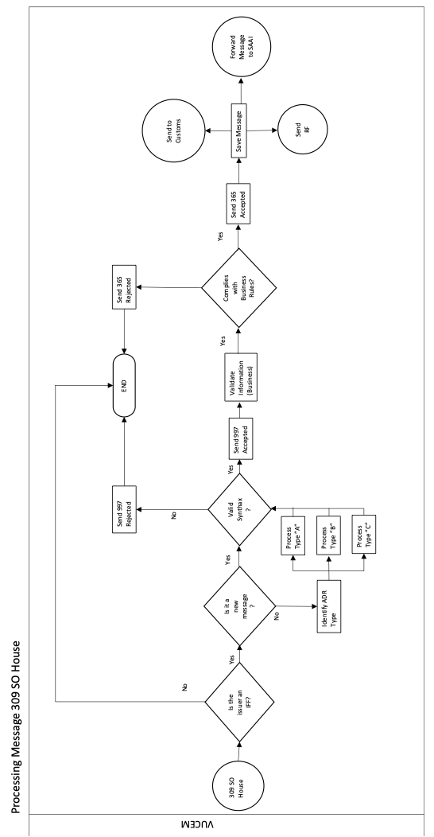

# **VI. Web services**

The maritime transportation companies, the international freight forwarders or their authorized parties, may carry out the exchange of information by means of web services, using a file in an XML format.

In general, the web service is a software designed to support the interaction between machines, by means of a net, in an interoperative manner. It has an interface described in a processable format by a computing equipment and is executed in a remote reception system, which usually refers to clients and servers that communicate via web using XML files.

The web service for the transmission is the Maritime Manifest 309 SO, which has the function of receiving a message and making the following validations:

* **Syntax**: Includes the performance of the validation that the message is in compliance with the syntax set forth and defined for each kind of petition.
* **Structure**: That the message has the structure defined in the XSD file, which determines if it is correct or not according to the requested petition.
* **Business**: The web service must validate that the information that is being entered in the message is correct; pursuant to business rules set forth for each kind of petition.

Consequently, the information transmitted must comply with the indications in the catalogs attached to these guidelines.

After such validations; the responses will be obtained, these will show if the message was processed correctly or if it does not comply with any of the validations.

Likewise, the persons that transmit, must have a web service for receiving the validation replies, which will be sent to the <URL> address set forth in the heading of the 309 message.

In order to transmit by means of the web service is necessary to take into account the following:

* The user must be registered in the Digital Window.
* Have an information technology development for the transmission of the information.
* Have an information technology development for the reception of the replies.
* The request to be sent must be contained in an XML file.
* Have a username and password, as it must be inserted in the heading of the XML message of the 309 SO.
* Have an active and valid CAAT registry with a shipping line, port ship agent, or international freight forwarder profile.

1. **WS Implementation**

The agreement of the web service (wsdl) to transmit, is found in the **file 1.1** and in **file 1.2** contained in Annex **1 "WS Implementation"**.

Likewise, in such exhibit in file 1.3, the XSD with which the messages shall comply with is found.

## **EDI 309 SO Message**

The 309 SO message is the transmission to the Customs authorities, in an electronic document, containing the information related to the goods and their transportation, before their arrival or exit to/from national territory

The structure of the 309 message is specified in the **file 2.1** contained in **Exhibit 2 “EDI 309 SO Message”**

The enforceability of the segment and/or elements are found in the same exhibit 2 in the **file "2.2. MUM Data Specification"**, according to the person transmitting or what transmission is made, likewise in such annex an example of the message can be found.

In the same way, in such annex in the **file 2.3** an example of the message can be found.

## **Types of EDI 309 SO message, pursuant to the operation:**

### **Manifest**

The carrier company must transmit the 309 message with the information of the manifest, which will contain a list of Master bills of lading from 1 to 9999.

### **House bill of lading.**

This message is transmitted by the international freight forwarders or its authorized parties, in the terms set forth in Rule 1.9.23 RGCE, one house bill of lading per message can be transmitted, namely, one transmission must be made for every house bill of lading you wish to send. In the **Exhibit 4** an example of the house bill of lading is shown.

### **In case of vessels in ballast**

A notice has to be given by the carrier company regarding a vessel without cargo, but that contains material to provide stability for the vessel while sailing, and that is not considered international trade goods.

For this scenario a 309 SO message must be transmitted, with the information of the vessel and manifest data, in the segments corresponding to the "bill of lading", "individuals", "goods", and "container", and must be declared with the tags defined for such scenario, in **Exhibit 5** an example of ballast vessel is found.

### **Empty container**

A 309 message must be transmitted with the information of the vessel, manifest, and container, in which in the segment "state of container" "E" (Empty) must be shown, in **Exhibit 6** an example of the information to be transmitted in case of an empty container is found.

### **Local costal trade manifest**

The carrier company must transmit the EDI 309 message with the information of the local coastal trade manifest, where segment M1201 must show the code “63”, as well as the national ports of origin and destination of the goods. One local coastal trade manifest may be transmitted per message, therefore the report of all the coastal trade cargo of a port, might contain one bill of lading and will be transmitted in one unique “M11” segment, in Annex **7** an example of a local coastal trade manifest is found.

### **Frequent errors when transmitting a 309 SO message**

The frequent errors are found in **Exhibit 8.**

### **The addendums and deletions, amendments to the 309 SO (ADR) message**

A 309 SO message can be amended, in order to add or delete bills of lading, add, delete, or replace information about the goods, as well as the data of the shipper/notify party /consignee/container etc., regarding a bill of lading.

The types of existing amendments are:

* “A” Add Bill of Lading.
* “D” Delete Bill of Lading.
* “R” Replace one or more segments of a Bill of Lading.

It is necessary to substitute segment M11 by segment M13, the data included in the M1303 field, must show if the amendment refers to an “A”, “D”, or “R”, as shown below:

### **Add bill of lading**

In order to add a bill of lading an “A” (M1303=”A”) must be added.

The keys for adding a bill of lading “A” (Add a Bill of Lading) are the following:

|  |  |
| --- | --- |
| **Key** | **Description** |
| **02** | Error in the declared information, the goods were not shipped and will be sent in a latter transport, based on documentary evidence. |
| **11** | Missing – For omission in the manifest due to an administrative error. |
| **12** | Surplus, for cargo to be unloaded at another port and by an oversight it was unloaded at this port. |
| **22** | Merchandize loaded but not manifested. |

### **Deletion of a bill of lading**

When a deletion is required to be made a (M1303=”D”) must be declared.

The keys for the deletion of Master or House bills of lading are:

|  |  |
| --- | --- |
| **Key** | **Description** |
| **01** | Goods not shipped pursuant to evidence filled by the shipper abroad or corrected bill of lading. |
| **02** | Error in the declared information, the goods were not shipped and will be sent on a latter transport, based in documentary evidence. |
| **04** | Theft or anticipated unloading prior to arrival to national territory, pursuant with the declaration signed by the Captain of the vessel, the shipping agent or a fragment of the ship's logbook on file. |
| **11** | Missing. |
| **12** | Surplus for cargo declared to be discharged at another port and that was discharged at this port. |

### **Replace or amend one or all of the segments of the bill of lading**

The (M1303=”R”)amendment, will be used to replace information of one or all of the segments of a registered bill of lading, it must be point out that, the content of this message substitutes all the received elements or segments. Such amendments will be associated to the rejection causes and time in which the replacement is filed pursuant to the following:

The information to be updated depends on the chosen cause (the cause will be placed in element M1306).

The keys to make an amendment or replacement are the following:

|  |  |
| --- | --- |
| **Key** | **Description** |
| **03** | Writing mistake in the manifest for bill of lading in the files. |
| **17** | Goods removed from the original container and refilled as part of a transshipment operation. |
| **18** | The goods were incorrectly input at origin. |
| **19** | Rectification of fiscal area. |
| **20** | Change of person, until before the entry to the fiscal area. After the entry, it will be a pending request of the fiscal area. In both cases, the goods corresponding to this bill of lading, must be in stock in the fiscal area (is must not have an exit status). |
| **21** | Rectification of data of a house bill of lading referenced to another house bill of lading. |
| **23** | Validate the entry to the area. This cause is due to a prior rejection of the declared information and the physically arrived at the fiscal area, where, the fiscal area captures the correct information and must match with the information of the bill of lading. |

### **Errors when making an addendum.**

|  |  |
| --- | --- |
| **Key** | **Description** |
| EX01 | Incorrect information in the Segment. The system identifies that incorrect information was declared in the segment. |
| EX02 | Duplicated bill of lading. The system identifies that the number of the bill of lading + CAAT has been previously registered. |
| EX03 | Invalid amendment cause. The system identifies that the amendment cause is incorrect for the type of amendment declared. |
| EX04 | Incorrect type of bill of lading. The system identifies that the information of the declared elements is incorrect. |
| EX05 | Incorrect information of the elements. The system identifies that the information of the declared elements is incorrect. |
| EX06 | Amendment of a non-existant manifest. The system identifies that the manifest to be amended does not previously exist in the Digital Window. |
| EX07 | Unregistered information at the Digital Window. The system identifies that there is no existing information registered at the Digital Window. |
| EX08 | Invalid segment. The system identifies that an invalid segment was declared. |
| EX09 | Duplicated bill of lading. The system identifies that the number of the bill of lading + CAAT has been previously registered. |
| EX10 | Invalid Fiscal Area. The system identifies that the key of the fiscal area (N902) does not correspond with the port declared in P401. |
| EX11 | Prohibited amendment of information. The system identifies that there is amended information that is not allowed. |
| EX12 | Amended port. The system identifies that the port has been amended. |
| EX13 | Incorrect amount. The system identifies that the amount is incorrect. |
| EX14 | CAAT not registered or not valid. The system identifies that the CAAT is not registered or is no longer valid. |
| EX15 | Incorrect code. The system identifies that the declared code is not valid in the catalogue. |
| EX16 | Required information not declared. The system identifies that required information has not been declared. |
| EXP17 | Uncontrolled error. An unexpected error occurs in the system. |
| **Frequent errors when replacing or amending** | |
| **Key** | **Description** |
| EX01 | Incorrect information in the segment. |
| EX02 | Invalid cause of amendment. The system identifies that the cause of amendment is incorrect for the type of amendment declared. |
| EX03 | Incorrect type of bill of lading. The system identifies that the type of bill of lading declared is incorrect. |
| EX04 | Incorrect information of the elements. The system identifies that the information of the declared elements is incorrect. |
| EX05 | Unregistered information in the Digital Window. The system identifies that there is no registered information in the Digital Window. |
| EX06 | Invalid segment. The system identifies that an invalid segment was declared. |
| EX07 | Bill of lading not found. The system identifies that the number of the bill of lading + CAAT is not previously registered. |
| EX08 | Invalid fiscal area. The system identifies that the key of the fiscal area (N902) does not correspond to the declared port in P401. |

## 

|  |  |
| --- | --- |
| **Key** | **Description** |
| EX10 | Invalid state of fiscal area. The system identifies that the state of the bill of lading d of the RF [sic] (fiscal area) is not valid. |
| EX11 | Incorrect code. The system identifies that the declared code entered is not valid in the catalogue. |
| EX12 | Undeclared required information. The system identifies that there is undeclared required information. |
| EX13 | Incorrect code. The system identifies that the declared code entered is not valid in the catalogue. |
| EX14 | Unregistered or not valid CAAT. The system identifies that the CAAT is not registered or is no longer valid. |
| EXP15 | Uncontrolled error. An unexpected error occurs in the system. |

### **Responses 997 and 355**

To the sending of a 309 SO message, a 997 acknowledgement corresponds and in case of finding errors in the structure, the retransmission of the message with the correct structure will be necessary.

When a 997 message accepted is obtained, the response to the 355 may be obtained. If an accepted and registered 355 is obtained, the information referred to in Rules 1.9.22. y 1.9.23. shall be deemed to be transmitted, on the contrary, if a 997 rejection or 355 rejection is obtained, the manifest will not be deemed as transmitted, in the attached files the structure of each message is described.

Likewise, **Exhibit 10** shows the WSDL and XSD that the users’ web services must comply with in order to receive the 355 responses by the Digital Window.

# **Queries in the Internet webpage.**

The foreign trade users can make queries in the internet webpage of the Digital Window of their transmitted 309 SO messages.

In order to file queries it will be necessary for the user to have a registered and effective session in the Digital Window portal.

The registration will be as follows:

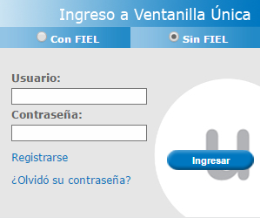

The following queries can be made:

1. Query of 309 Message
2. Query of container
3. Query of house bill of lading
4. Query of maritime manifest
5. Query of master bill of lading
6. Query of Log
7. Query of movements in the Manifest

## **Query of 309 message**

There are 3 search filters:

* **Customs:** The name of the customs and date of transmission must be chosen.
* **Manifest Number:** The number of the manifest must be entered.
* **Shipping Company:** The CAAT must be entered.

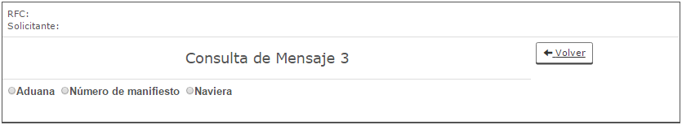

In any of the 3 selected search filters the following information will be visible:

* Manifest number
* Estimated Date of Arrival/Departure
* Date of Receipt/Transmission
* Baplie

Hereafter, the Query "Query of 3 Message" is shown, using the **Shipping Company** filter.

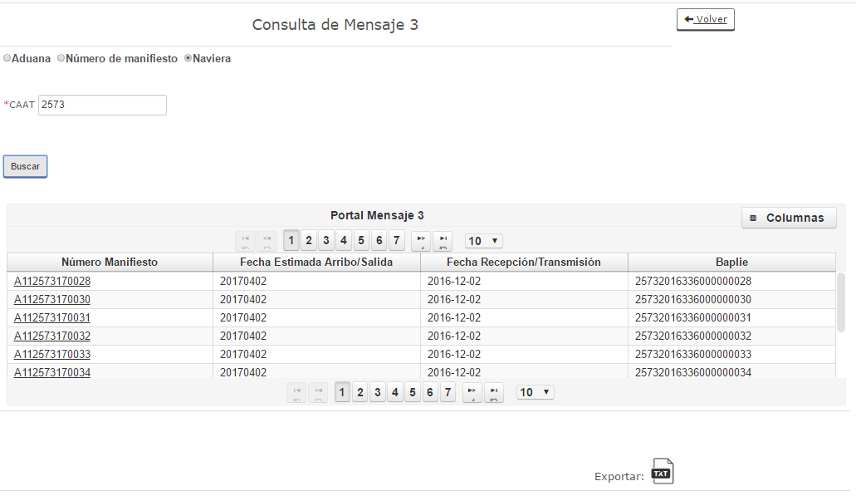

The consulted information can be exported, by clicking the icon "Export", by doing so, the system will show a Query number, which will be accessible for a maximum term of 7 calendar days, as of the day the download was made.

Example:

A query was downloaded on the 1-04-2017 (Number: 201704010200001), the number will be available for download afterwards until de the 7-04-2017.

Screen for downloading Queries with the Number of Query provided by the system.

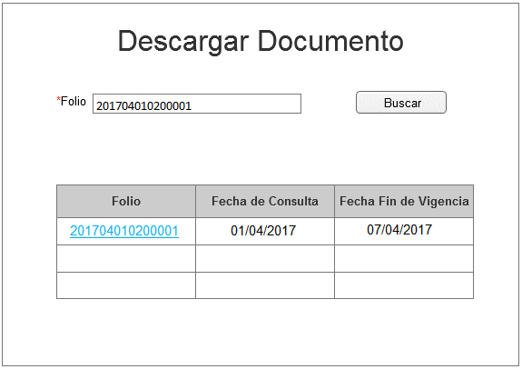

The user that makes a query, must enter in the checkbox *Number, the number that the system showed when downloading the .txt file (click in the icon “**Export**”), afterwards, click the search button and the number information will be shown.

The number will be shown in blue color and by clicking the number, the file will be downloaded.

## **Container query**

There are 2 search filters:

* **Customs:** select the Name of the Customs, Transmission Date and enter the Name of Vessel and Container Number.
* **Container:** enter the number of Container.

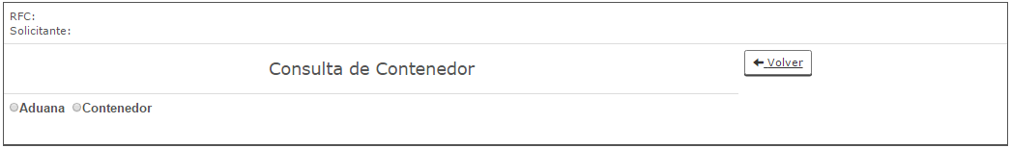

In any of the 2 search filters selected the following information will be shown:

* Number of Container
* Type of Container
* Status of the Container
* Seal Number
* General Description
* Mark and Numbers
* Total Number of Pieces
* Gross Weight/Volume
* Type of Person (Shipper, Consignee, Notify to)
* Shipper Name
* Shipper Domicile
* Consignee Name
* Consignee Domicile
* Name Notify Party
* Domicile Notify Party

Hereafter, the "Container Query" is shown, using the filter **Customs.**

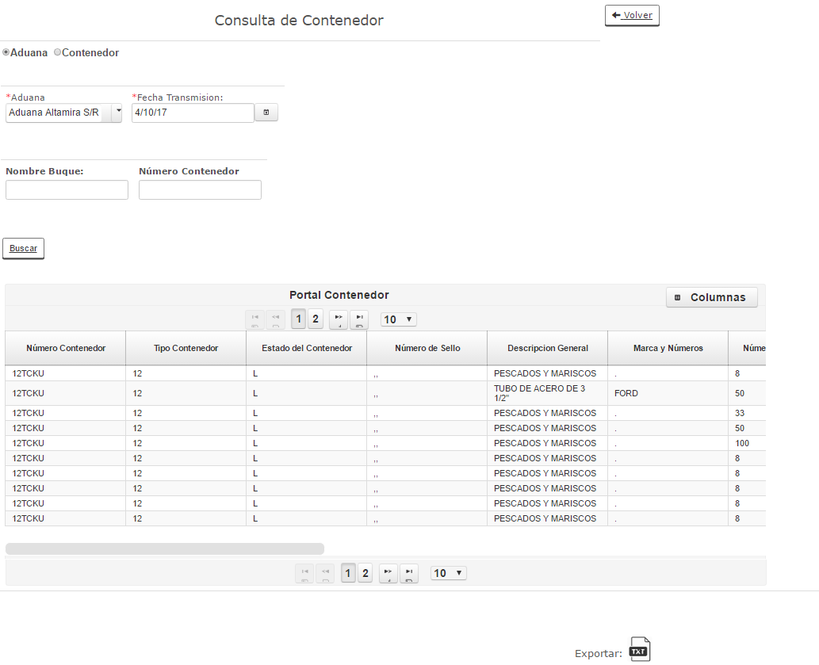

The user can export the Queried information, by clicking the icon "Export", by doing so, the system will show a Query number, which will be accessible for a maximum term of 7 calendar days, as of the day the download was made.

Screen for downloading queries with the Number of Query provided by the system.



The user that makes a query, must enter in the checkbox *Number, the number that the system showed when downloading the .txt file (click in the icon “**Export**”), afterwards, click the search button and the number information will be shown.

The number will be shown in blue color and by clicking the number, the file will be downloaded.

## **House bill of lading query**

There are 2 search filters:

* **Customs:** select the Name of the Customs, Transmission Date and enter the Manifest Number and Name of Vessel.
* **House Bill of Lading:** enter the House Bill of lading.

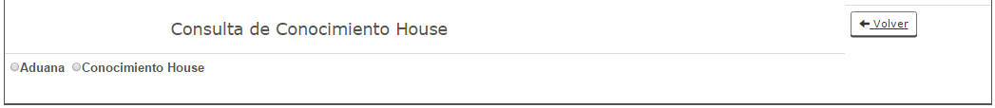

In any of the 2 search filters selected the following information will be shown:

* Customs
* Manifest Number
* House Bill of Lading Number
* Type of House Bill of Lading
* Loading/Unloading
* Port of Origin
* Type of Person (Shipper, consignee, notify to)
* Shipper Name
* Shipper Domicile
* Consignee Name
* Consignee Domicile
* Name Notify Party
* Domicile Notify Party

## **Manifest query**

There are 3 search filters:

* **Customs:** select the Name of the Customs and the Transmission Date.
* **Vessel:** enter the Name of the vessel and select the Transmission Date.
* **Manifest:** enter the Manifest Number.

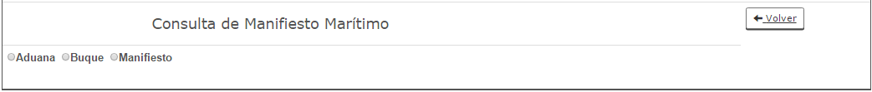

In any of the 3 search filters selected the following information will be shown:

* Manifest Number
* Type of Operation
* ETA/ETD Date
* Validation Date

Hereafter, the "Maritime Manifest Query" is shown, using the filter **Manifest.**

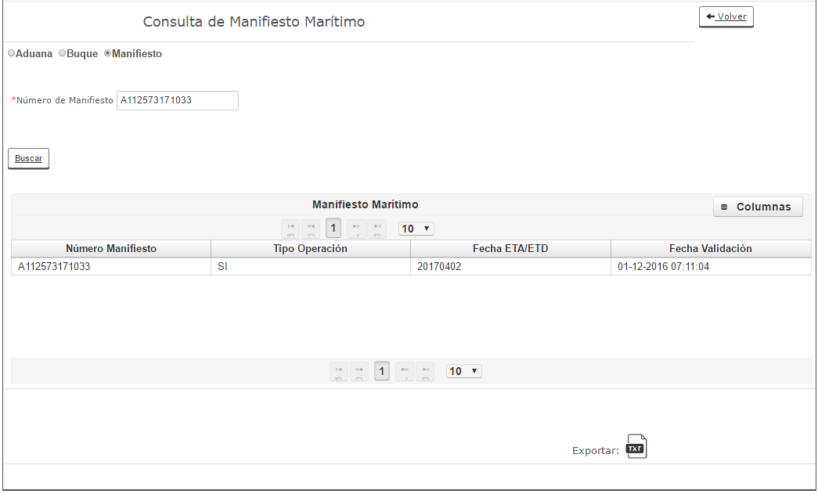

The user can export the Queried information, by clicking the icon "Export", by doing so, the system will show a Query number, which will be accessible for a maximum term of 7 calendar days, as of the day the download was made.

Screen for downloading Queries with the Number of Query provided by the system.



The user that makes a Query, must enter in the checkbox *Number, the number that the system showed when downloading the .txt file (click in the icon “**Export**”), afterwards, click the search button and the number information will be shown.

The number will be shown in blue color and by clicking the number, the file will be downloaded.

## **Master bill of lading query**

There are 2 search filters:

* **Customs:** select the Name of the Customs, Date Transmission Date and enter the Manifest Number and Name of Vessel.
* **Master Bill of Lading:** enter the Master Bill of Lading.

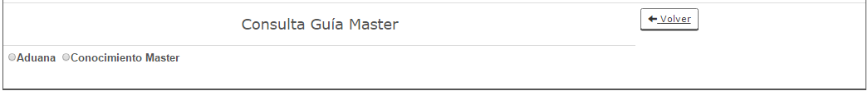

In any of the 2 search filters selected the following information will be shown:

* Customs
* Manifest Number
* Master Bill of Lading Number
* Type of Master Bill of Lading
* Port of Loading/Unloading
* Port of Origin
* Port of Transshipment
* Port of Local Costal Trade Manifest

Hereafter, the "Master Bill of Lading Query" is shown, using the filter **Customs**.

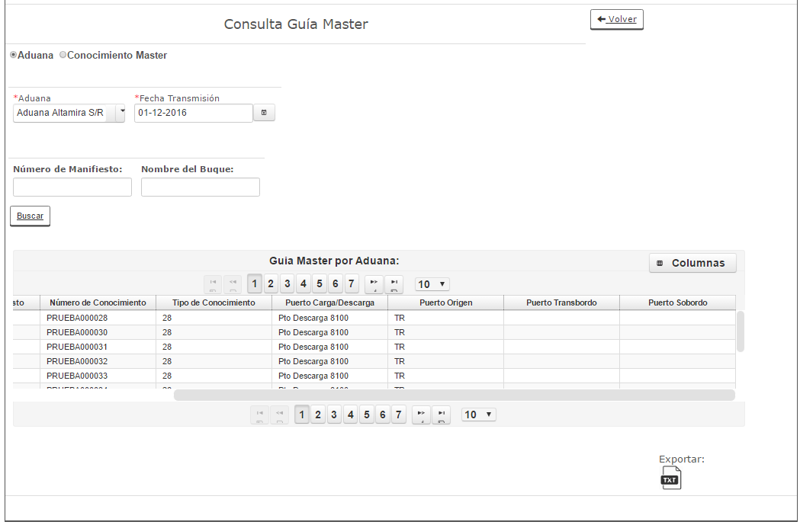

The user can export the Queried information, by clicking the icon "Export", by doing so, the system will show a Query number, which will be accessible for a maximum term of 7 calendar days, as of the day the download was made.

Screen for downloading Queries with the Number of Query provided by the system.



The user must enter in the checkbox *Number, the number that the system showed when downloading the .txt file (click in the icon “**Export**”), afterwards, click the search button and the number information will be shown.

The number will be shown in blue color and by clicking the number, the file will be downloaded.

## **Log query**

There are 2 search filters:

* **Petition:** enter Petition ID.
* **Date:** select a date**.**



In any of the 2 search filters selected the following information will be shown:

* Petition ID
* Status

Hereafter, the Log Query" is shown, using the filter **Date**.

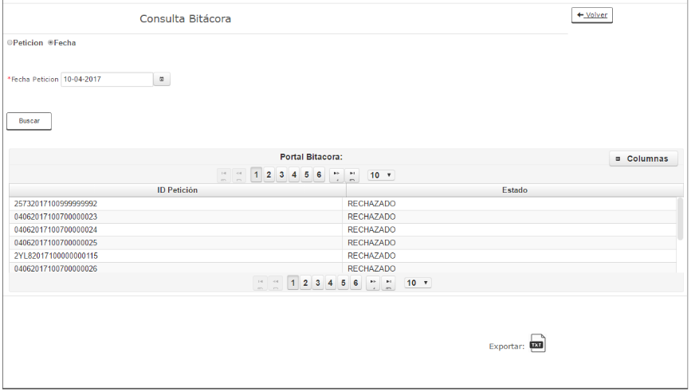

The user can export the Queried information, by clicking the icon "Export", by doing so, the system will show a Query number, which will be accessible for a maximum term of 7 calendar days, as of the day the download was made.

Screen for downloading queries with the Number of Query provided by the system.



The user that makes a Query, must enter in the checkbox *Number, the number that the system showed when downloading the .txt file (click in the icon “**Export**”), afterwards, click the search button and the number information will be shown.

The number will be shown in blue color and by clicking the number, the file will be downloaded.

## **Manifest movement query**

There are 2 search Filters:

* **Transportation Document:** one pre-filter must be selected:
* Master Maritime Guide, enter the Master Bill of Lading
* House Bill of Lading, enter House Bill of Lading
* Manifest, enter the Manifest
* **Date:** select a range of dates (initial date and final date)

